***Documentation For Specifications for Particle Effect***

The effects below are created within the appParticle Editor.

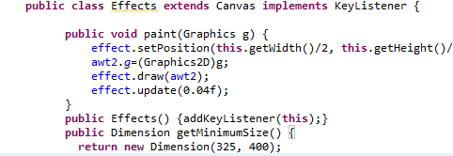NOTE: Based on the source code, it seems that all particle effects cannot be of a size greater than 325x400

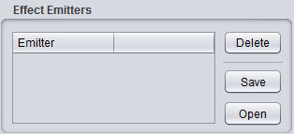

1. Opening a file.
2. In the bottom left corner of the program click "Open"
3. navigate to the softwareruse folder: then go here softwarereuse-->data   . . .open "foo.p"
4. now, on the right on the program, under "Emitter properties" , scroll to the top under "Image" and click "Open"
5. Go to softwarereuse-->data , scroll down to where you see the "particle" file. open it and Begin testing!
6. - Note: you can open the file "Particle " ,"Particle-Cloud","Fire" , or "Star"  .  Your preference.
7. once open you can begin testing. **Test by clicking in the space and holding the SpaceBar or any key**
8. 6.) you can change the variables in many different ways and see how the particle changes.

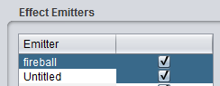2.)Effect Emitters – Here’s everything you need to know in the “Effect Emitters” section.

1. Open-As you previously seen in the last step, If you Click “Open” it opens the window explorer and lets you pick a file to open. When selecting a file to open please open a “.p” file.
2. You can Double Click the Emitter name and change it. The default text value is “untitled”
3. Check Box- If the check box is unchecked, the emitter will not show. And vice-versa
4. Under the “Emitter” section you will see the file(s) you have.
5. Delete- You can click on one of your files and click the “Delete” button to delete it**.THE DELETE BUTTON CURRENTLY DOES NOT WORK!**
6. Save- After changing settings to your “.p” file you can click the “Save” button and all of your settings for that “.p” file will be saved. Remember to put “.p” after the name when saving your file. (i.e- if you wanted to name something “myFile” you should save it as “myFile.p”)

*Editor Properties:*

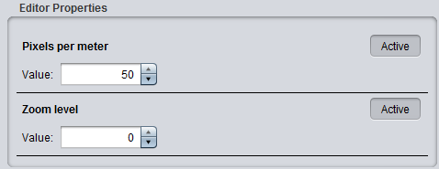3.) Pixels Per Meter - To activate and make changes you can click the “Active” button or you can hover over the text “Pixels per Meter” until your cursor changes to a hand then click.

1. 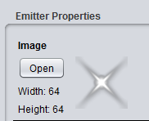Had NO effect on any part of the program.

4.) Zoom Level – Had **NO** Effect

5.) **Image** – Here’s where you open the actual particle that you will be using in the program. Click “Open” to bring up a dialog box and search for your particle to open. Once open, your particle will show to the right of the image section closely zoomed in for the naked eye to see.

C:\Users\Adrian\Documents\Spring 2013 Classes\OOD\Project 1-Document appParticleEditor\ScreenShots\6-Delay.PNG6.) **Delay** – Delay delays the motions that the particle normally goes through in the program. Periodically throughout the program the particle will seem like it slowed down when it is actually delayed. It will still continue its normal path but will reach the end much slower. The higher the delay value the more the program is delayed.

C:\Users\Adrian\Documents\Spring 2013 Classes\OOD\Project 1-Document appParticleEditor\ScreenShots\7-Duration.PNG7.) **Duration** – Duration effects how long the particle last on the screen. The higher the duration value, the longer the particle when run when you press and hold the spacebar (or any key).

1. Count: The Min function if raised increases the number minimum number of particles that can produce in the app. The Max function is the max number of particles allowed on the screen at one time.

MacBook Pro Hard Drive:Users:knicklover2001:Desktop:Screen Shot 2013-03-10 at 8.32.31 PM.png

1. Emission: is that which is sent out, issued, or put in circulation at one time. The High lets you choose how many particles you want circulating at one time. The Low lets you choose what the lowest number are.

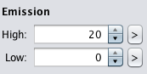

1. Life: Specifies a time limit on emitter life if have any value (1 means 1 sec , or infinite life time if 0. Does not apply to non-Continuous effects, which are always disappear as soon as they emit their particles.

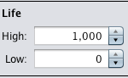

1. Life Offset: How much life is used up when a particle spawns. The particle is still moved/rotated/etc for the portion of its life that is used up. This allows particles to spawn, eg, halfway through their life.

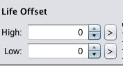

1. X- Offset and Y-Offset: The amount in pixels to offset where particles spawn in the particle editor

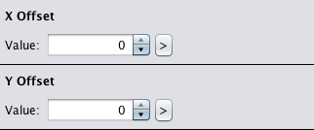



1. Spawn

* Shape: has no function or it doesn’t work correctly.
* The shape can be a line, square, ellipse, and point

1. Spawn Width

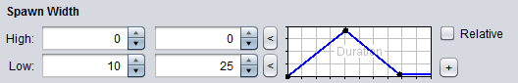

* I’m not sure if this part is working properly I think it is supposed to set the spawn width for the shape specified but it doesn’t seem to function right
* This part is only active if the Spawn Shape is set to line, square or ellipse
* 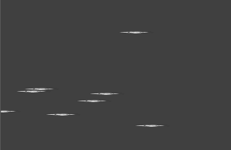The only part that has functionality is the low when it is set it stretches the particle size to the width put in the low boxes
* When low is set to 10 to 25 and on Spawn Height low is zero for both it produces

1. Spawn Height

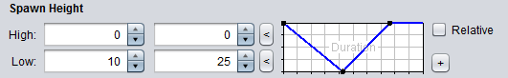

* This part is only active if the Spawn Shape is set to line, square or ellipse
* 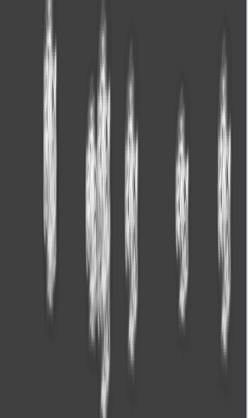Works with Spawn Width only the low has any effect on the particle same as Spawn Width
* When low is set to 10 and 25 and spawn width low is set to zero it produces stretched out particles in the vertical direction
* If Spawn Width has a relatively close value to the low value of the height it will make a normal looking shape as large as the size specified in the size part
* Relative has no effect

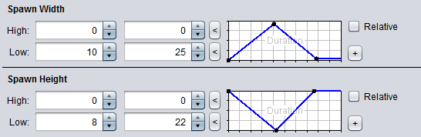

* When both the spawn height and spawn width lows are set near each other it makes a normal looking particle object such as 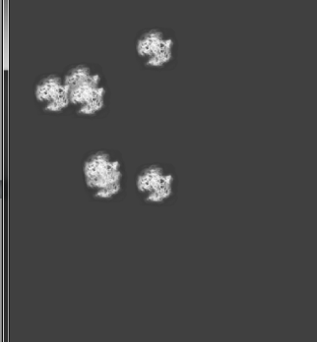

1. 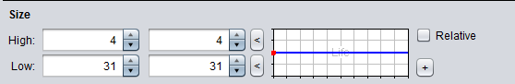Size

* Changes the size of each particle
* The blue line on the graph is the percentage of the high or low that it uses since it is in the middle half of the sizes will be 4 according to high and half will be 31 like low.
* You can set the size between any two numbers that are placed in the two spaces for high and for low causing a mixture of sizes between the numbers specified
* Relative appears to have no effect

1. 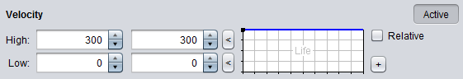Velocity

* The higher the high or low values are the space where the particles are created is increased and the lower the values for high and low are the smaller the space for the particles to be created in.
* If the values are closer to zero it puts the particles in a line 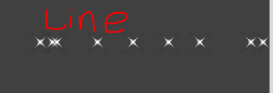

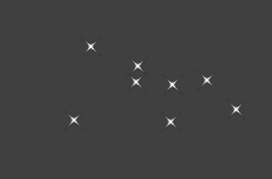 this is when the velocity is above or below zero the farther the number is away from zero the larger the space the particles are allowed to occupy

* Active turns this on or off
* Relative seems to have no effect
* The blue line on the graph determines if the high or low values are selected or a mixture of the two

1. Angle

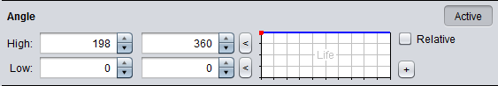

* This seems to make the area for the particles to occupy bigger or smaller depending on the high and low values very similar to the velocity part
* Although if either velocity or angle is near zero it puts all the particles in a line so even if angle has value far from zero and velocity is zero then it will still be in a line like
* The blue line on the graph determines if the high or low values are selected or a mixture of the two
* Active turns this part on or off

*Emitter Properties:*

1. **Rotation** – The rotation property turns the particle about its center. The High input field turns the particle from a more vertical position to a horizontal one. Inputting a negative integer causes the particle to turn back (lean) to its left, until it is completely horizontal. A positive integer turns the particle to its right until it is completely horizontal. When an integer is put into the Low input field, whether it is negative or positive, the particle remains in an upright vertical position. There are no rotational effects with the Low input field. The graph determines what percentage of the particles will rotate over their lifespan duration.

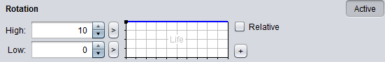

2.) **Wind** – This property simulates the effects of wind on a particle. The “Active” button activates these properties fields. The Low Input has no functionality, probably since wind is an increasing state. The High input field may be filled with any random number based on the value found in the High input field from the Life property. The larger the value gets the more the particles are dispersed over the Emitter. Values that are close to 0, don’t disperse particles very far from one another, hence particles are more often found grouped with one another. The graph is used as an indicator for how many particles should be affected by the wind property during its life span.

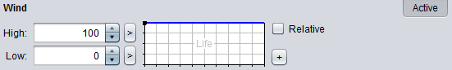

3.) **Gravity** – This property simulates the effects of actual gravity on a particle. It is activated when the “Active” button is clicked and parameters are put in for either the High or Low input fields. An arbitrarily large value for the *High* input results in particles being pushed or seemingly “floating” downward, when the value is positive. When the value for the *High* input is negative, particles seem to be pushed or float upward, simulating a lack of gravity. This float is caused by the High and Low inputs used for the Life property. The gravity input carries the particle closer to these coordinates simulating gravitational pull.

The Low Input seems to simulate the effects of extreme gravity on the particles. The particle remains at the low and doesn’t move, as if it is weighed down. The graph is used to apply this gravity over a percent of the particle’s lifespan.

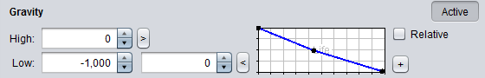

**Note:** The Rotation, Wind, and Gravity properties all work hand in hand with the Life property. There must be a referable value in the input fields for the Life property in order to get desired effects.

4.) **Tint** – Allows you to change the color your particle exhibits, not all particles are displayed in the chosen color. The “all white” spectrum seems to allow the user to place tick mark indicators and display different arrays of color at each one, similar to a test strip. Once a desired color is displayed you may choose to display it by choosing the corresponding indicator. The “rainbow-colored” spectrum provides the basis for choosing a particle color. There are two shorter spectrums that display a range of shades for the chosen color. The short spectrum on the left is used to create light shades for your chosen color and can be used to produce a white particle. The short spectrum on the right is used to produce bolder shades for your chosen color and can also be used to produce a particle that is black in color.

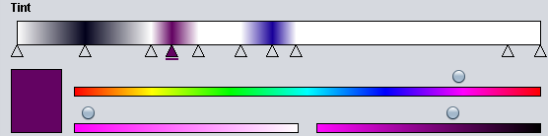

5.) **Transparency** - The ability of the particle to be seen through. Functionality is seemingly minimal when spawn shape is set to point; however, when spawn shape is set to line, ellipse, or square and combined with changes to spawn width or height, the effects are more noticeable. The particle becomes more “see-through”. The relative line graph function below sets a standard for the level of transparency for a given percentage of particles that have been created. Therefore, allowing you to have a percent transparency of a percent of a particle lifespan.

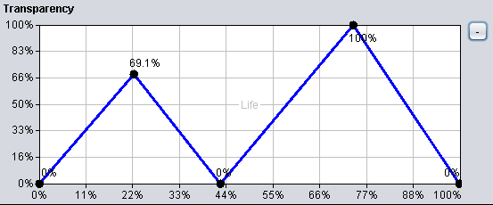

.

6.) **Options** – The Options tab provides several checkboxes for altering the behavior of particles.

**A. Additive:** Has no functionality.

**B. Attached:** This feature, when checked, gives particles the ability to move simultaneously, in the same direction when they come in contact with one another during particle lifespan. This gives the appearance of two connected particles moving together as one.

**C. Continuous:** This behavior allows for continuous creation and cycling of a particle through its lifespan, when checked. When unchecked, particles are created and cycle through their lifespan only once before they are terminated and disappear from the Emitter screen.

**D. Aligned:** This behavior allows particles position to remain unchanged when checked. Particles may lie horizontally, diagonally or vertically across the Emitter screen. When unchecked, particle position may begin horizontally, diagonally, etc. but after continuous lifespan cycling the particles will eventually all be vertically aligned in position.

**E. Behind:** Doesn’t seem to function fully. I think this was intended to control the presence of overlapping particles. Particles continue to overlap when the *behind* feature is unchecked as well as checked. However, when this attribute is unchecked the presence of overlapping particles does seem to decrease.